WEEK 1 DELIVERABLE: DATA SCIENCE PROBLEM DEFINITION & RESEARCH BLUEPRINT

Project Title: Predictive Customer Churn Mitigation & Repeat Purchase Optimization in D2C Skincare

Industry Vertical: Beauty & Wellness (Direct-to-Consumer / Subscription E-Commerce)

Author: Tanmay Pralhad Hirnak (Data Science Intern)

Date: 03 October 2026

TABLE OF CONTENTS
1. Executive Summary & Industry Context
- 1.1 Industry Background & Market Dynamics
- 1.2 Target Enterprise & Business Challenge
2. Business Problem Statement & Core Objectives
- 2.1 Problem Statement
- 2.2 Core Project Objectives
3. Research Questions & Formal Hypotheses
- 3.1 Research Question 1 (Digital Regimen Engagement) & Hypothesis 1 ($H_1$)
- 3.2 Research Question 2 (Customer Support & Sentiment Drift) & Hypothesis 2 ($H_2$)
- 3.3 Research Question 3 (Skin Type & Product Fit Volatility) & Hypothesis 3 ($H_3$)
4. Key Variables & Potential Data Sources
- 4.1 Taxonomy of Variables (Data Dictionary)
- 4.2 Data Sourcing Strategy & Public Resource Integration
5. Proposed Step-by-Step Analytical Approach
- 5.1 Six-Phase Project Lifecycle Architecture
- 5.2 Key Analytical Milestones & Tooling
6. Justification & Business Impact
- 6.1 Strategic Rationale
- 6.2 Anticipated Business ROI & Value Creation
7. Conclusion

1. Executive Summary & Industry Context

1.1 Industry Background & Market Dynamics
The Direct-to-Consumer (D2C) Beauty & Wellness sector has experienced significant structural changes over the past five years. While digital-first brands initially benefited from low acquisition costs on major ad platforms, recent privacy frameworks, ad-tracking restrictions, and market saturation have driven Customer Acquisition Costs (CAC) up by 40% to 60%. Consequently, brand profitability is no longer driven by single transactions, but by maximizing Customer Lifetime Value (CLV) through recurring orders and subscription retention.

In skincare and cosmetics, customer retention is uniquely tied to product consumption cycles and dermatological realities:

- Product Depletion Timelines: Most standard skincare regimens (e.g., 50ml serums, cleansers) are formulated for a 45-to-60-day consumption cycle.

- The "Purging" Abandonment Phase: Customers frequently experience temporary acne breakouts or skin adaptation during the initial 14 to 28 days of using a new regimen (dermatological cell turnover). Without early engagement or guidance, customers mistake skin purging for an adverse reaction and abandon the product before seeing positive results.

- Subscription Fatigue: Unplanned auto-shipments without routine check-ins lead to product stockpiling, resulting in abrupt subscription cancellations.

1.2 Target Enterprise & Business Challenge
This project focuses on Aura Care, a mid-market D2C skincare brand specializing in targeted routines for complex skin conditions. Historical data indicates that Aura Care faces a 62% customer churn rate within the first 90 days post-purchase.

Currently, the brand relies on reactive retention—sending automated discount coupons after a customer cancels a subscription or misses a reorder window. This approach reduces profit margins and fails to address the root causes of drop-off.

2. Business Problem Statement & Objectives

2.1 Problem Statement
“Aura Care experiences a 62% drop-off in customer reorders within 90 days of initial purchase due to unmonitored product purging, lack of digital routine adherence, and unaddressed negative sentiment in support interactions. The business currently lacks a data-driven system to detect early warning signals of churn before the 60-day depletion window, leading to high CAC and diminished Customer Lifetime Value.”

2.2 Core Project Objectives
- Predictive Risk Scoring: Build a supervised binary classification system to accurately predict the probability of a customer churning ($Y=1$) or making a repeat purchase ($Y=0$) within 60 days post-purchase.

- Early Warning Signal Identification: Uncover key behavioral, transactional, and sentiment features that serve as leading indicators of churn during the critical 14-to-30-day post-purchase window.

- Automated Intervention Integration: Design an actionable framework that feeds model outputs into marketing automation tools (e.g., Klaviyo, Shopify API) to trigger personalized retention campaigns before product depletion occurs.

3. Research Questions & Formal Hypotheses
To guide our analytical modeling and exploratory data analysis, we establish three core research questions supported by testable, quantitative hypotheses:

Research Question 1 (Digital Regimen Engagement)
- RQ1: Does customer engagement with digital onboarding tools (such as routine setup quizzes, portal logins, and regimen guides) within the first 14 days post-purchase correlate with lower 90-day churn rates?

- Hypothesis 1 ($H_1$): Customers who log into the regimen portal or complete a routine tracker $\ge 3$ times within the first 14 days post-purchase will exhibit at least a 25% lower churn rate at Day 90 compared to low-engagement users, with statistical significance at $\alpha = 0.05$.

Research Question 2 (Customer Support & Review Sentiment Drift)
- RQ2: Can sentiment score degradation in customer support chats or product reviews predict subscription cancellations prior to the next scheduled billing cycle?

- Hypothesis 2 ($H_2$): A negative sentiment drift ($\ge 30\%$ drop in compound sentiment score using natural language processing) across customer support interactions is predictive of churn within 14 days, yielding an Area Under the Receiver Operating Characteristic Curve (AUC-ROC) $\ge 0.78$.

Research Question 3 (Skin Type & Product Fit Volatility)
- RQ3: Does churn severity vary significantly across specific skin types and purchase seasonality?

- Hypothesis 3 ($H_3$): First-time buyers with Sensitive or Combination skin types who make initial purchases during seasonal transitions (e.g., Autumn-to-Winter) experience a 15% higher churn rate than normal unless accompanied by a seasonal regimen modification recommendation.

4. Key Variables & Potential Data Sources
To solve this business problem, we will combine transactional, behavioral, demographic, and unstructured sentiment data from multiple public and simulated e-commerce sources.

4.1 Taxonomy of Variables
Variable Name | Data Type | Source System | Analytical Role | Description
customer_id | String / ID | Shopify / Database | Primary Key | Unique user identifier.
churn_label_60d | Binary (0/1) | Target Calculation | Target Variable | 1 if no repeat purchase/subscription active at 60 days; 0 otherwise.
recency_days | Integer | Order History | Predictor / Feature | Days elapsed since the last completed order.
frequency_orders | Integer | Order History | Predictor / Feature | Total count of orders placed to date.
monetary_value | Float | Order History | Predictor / Feature | Cumulative net revenue generated by the customer ($).
discount_ratio | Float | Checkout Logs | Predictor / Feature | Ratio of discounted amount to gross order total.
skin_type | Categorical | Routine Quiz | Predictor / Feature | Oily, Dry, Sensitive, Combination, Normal, or Unknown.
portal_logins_14d | Integer | App / Web Analytics | Predictor / Feature | Number of user portal sessions within the first 14 days.
support_tickets_30d | Integer | Zendesk Logs | Predictor / Feature | Count of support tickets submitted within 30 days.
avg_sentiment_score | Float (-1 to +1) | Text / NLP Output | Predictor / Feature | VADER / RoBERTa sentiment score from reviews and tickets.

4.2 Public Sourcing Strategy
Because direct corporate data is proprietary, we will compile and adapt publicly available datasets to simulate an enterprise environment:

- Kaggle E-Commerce & Cosmetics Interaction Datasets: Public clickstream and order transaction logs providing web behavioral patterns.

- Sephora / Beauty Public Review Archives: Web-scraped corpora containing explicit customer skin-type metadata, ratings, and unstructured review text.

- Shopify & Zendesk API Open Schemas: Standard relational structures used to build realistic synthetic data pipelines for user tickets and order histories.

5. Proposed Step-by-Step Analytical Approach
Our execution strategy spans six distinct phases over the internship lifecycle:

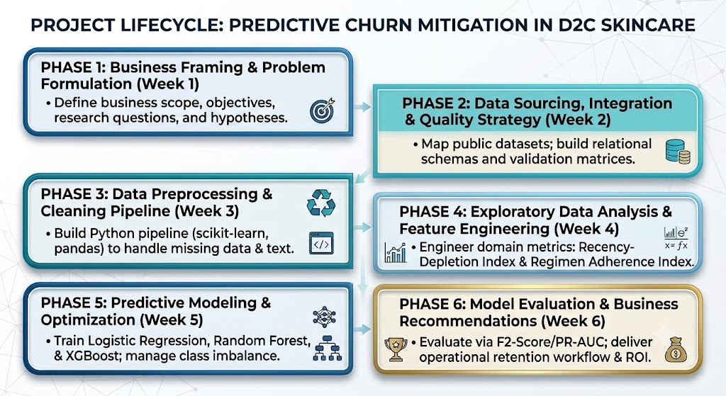

Analytical Milestones
- Data Ingestion & Cleaning: Apply robust imputations for missing skin metadata, standardizing volume units (ml vs. fl oz), and scaling continuous monetary metrics.

- Domain-Specific Feature Engineering: Construct custom features including:

  - Recency-Depletion Index (RDI): Measures how far past the expected product depletion date a customer sits without reordering.

  - Sentiment Drift Score ($\Delta S$): Quantifies shift in tone between initial onboarding reviews and recent support tickets.

- Model Selection & Cost-Sensitive Evaluation: Train and tune baseline models (Logistic Regression) against gradient boosted trees (XGBoost) using F2-Score and PR-AUC to prioritize capturing false negatives (unidentified churners).

6. Justification & Business Impact

6.1 Strategic Rationale
Focusing on predictive churn mitigation directly addresses the primary financial leak in modern D2C e-commerce. Retaining an existing customer is mathematically 5 to 7 times less expensive than acquiring a new one. By predicting churn risk during the product consumption lifecycle (Days 14–45), Aura Care can shift resources away from high-discount acquisition ads toward automated, low-cost, high-margin retention interventions.

6.2 Anticipated Business ROI
- Target Cohort: 10,000 active quarterly subscribers.

- Baseline Loss: 62% churn = 6,200 lost customers per quarter ($180 Average LTV $\rightarrow$ $1,116,000 lost potential revenue).

- Projected Model Benefit: Identifying 85% of churn-prone users early and saving 20% of those flagged via targeted skin-consultation workflows will retain approximately 1,054 customers annually, unlocking over $189,000 in saved net revenue.

7. Conclusion
This Week 1 blueprint establishes a clear, data-driven framework to transform Aura Care’s customer retention strategy from reactive discounting to proactive, predictive risk mitigation. By combining e-commerce transactional data, digital engagement tracking, and sentiment analysis, this project addresses the core drivers of early subscriber churn in the beauty and wellness sector. The proposed six-phase analytical approach directly aligns technical data science methodologies with strategic business outcomes, laying a solid foundation for the data collection, feature engineering, and predictive modeling tasks in the upcoming weeks.

